**Shelf Talk**

Your next pageturner awaits.

A Book Review SocWeb

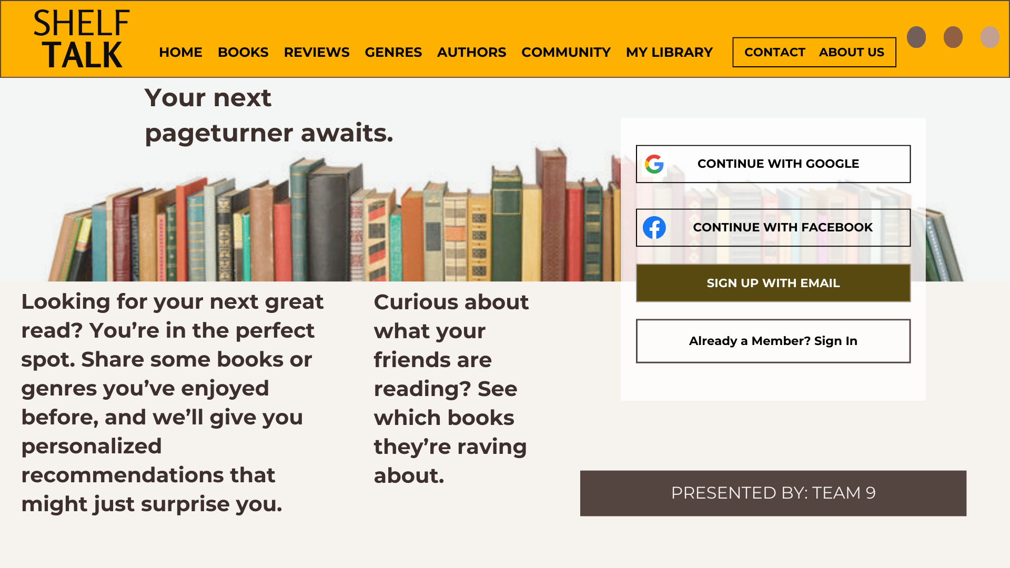

**SUBMITTED BY: TEAM 9**

Ella, Kiara Lohan

Laynes, Janel

Navida, Vianne Louie

Ibo, Gabriel.

**SUBMITTED TO:**

**Mhelrose B. Prades**

INSTRUCTOR

1. **WEB PAGE DESCRIPTION**

This generation where literature is rapidly evolving across the world. This website aims to give you satisfaction in exploring, reviewing, and discussing books. It is the gateway of communication between devoted readers and literary artists in sharing informational context, offering an interactive platform for sharing insights, critiques, and recommendations.

This website is a safe-place for avid readers to discover, give multiple perspectives, standardize, and discuss their favorite books. Users can explore different varieties of book reviews across various genres including fiction, non-fiction, mystery, fantasy, and self-help. This site is a user-friendly interface that allows visitors to quickly find book recommendations, view personalized reading lists, and interact with a vibrant community of fellow readers.

Every user has  a privilege to include detailed reviews, ratings, and give them an option to leave their thoughts and insights. The website also features author profiles and descriptions to provide readers with deeper insights about how their favorite books are made and works. The most-read book will be designed in the corresponding news feed of the user.

The webpage content is organized into various sections, distinguishing genres and reader age groups, ensuring suitable and enjoyable literature for all ages. Some other social platforms are not utilized by young people, making them adopt inappropriate ideals.

**Platform Features:**

* **Friends & Social Feed** - This feature allows users to connect with friends and fellow readers. Users can follow their friends' activities, such as the reviews they've written, books they’ve rated, or their recent reading lists on the Home page. It creates a more interactive experience by letting users see what books are trending among their social circle, encouraging discussions and shared reading experiences. Users can also comment and have discussion threads similar to Facebook posts or Reddit discussions.
* **User-Friendly Interface** - it can easily be understoodand navigateddue to its simple design and key features that can easily recognize how it works.
* **Enhanced Search Features** -it allows users to search specific criteria such as author, book title, genre, and other keywords that make this site productive and efficient to use.

**PAGE CHARACTERISTICS:**

**1. Home**

* **Social / User Activity Feed:** Display recent reviews, ratings, or comments from users.
* **Announcements/News:** Include any updates or special events related to books, reading challenges, or community news.
* **Personalized Greeting:** If the user is logged in, show a personalized greeting and suggest books based on their reading history.

### 2. Books

* **Book Listings:** Display a list of books with options to filter by popularity, rating, new arrivals, or alphabetical order.
* **Categories:** Allow browsing by category, such as Fiction, Non-Fiction, Mystery, Fantasy, Science Fiction, etc.
* **Search Functionality:** Provide a search bar to find books by title, author, or ISBN..
* **User Ratings & Reviews:** Display user reviews and ratings for each book with the option for logged-in users to add their own.

### 3. Reviews

* **Recent Reviews:** Showcase the most recent reviews from users.
* **Top Reviews:** Highlight the highest-rated reviews or most-liked reviews.
* **Search/Filter by Book:** Allow users to search reviews for a specific book.
* **Write a Review:** Provide a section where users can write their own reviews for books they’ve read.

### 4. Genres

* **Genre List:** Show a list of all book genres (e.g., Romance, Thriller, Sci-Fi, Biography, etc.).
* **Top Picks in Each Genre:** Display a selection of popular or recommended books in each genre.
* **Featured Authors by Genre:** List popular authors who write in that genre.

### 5. Authors

* **Author Directory:** A list of authors with brief bios.
* **Search by Author:** Allow users to search for authors by name.
* **Featured Authors:** Spotlight popular or trending authors.
* **Author Pages:** For each author, provide a bio, a list of their books, upcoming releases, and related news.
* **Author Interviews or Q&A:** If available, feature interviews or Q&A sessions with authors.
* **Follow Authors:** Let users follow their favorite authors to get updates on new releases or events.

**6. Community**

* **Community Feed:** A dynamic feed showcasing the latest discussions, events, and member activities.
* **Search Community:** A search bar that allows users to find members, topics, or discussions by keywords or tags. This helps users connect with others who share similar interests.

**7. My Library**

* **Reading Progress Tracker:** Monitor your reading progress with a percentage indicator for each book. Easily update your status as you read.
* **Personal Notes / Draft:** Add notes for each book to jot down thoughts, quotes, or insights as you read. These can be private or shared with friends. Create draft posts about your reading experiences or reviews that you can publish later. Organize your drafts by book or topic for easy access.

Additionally, users can set reading goals and track their progress through interactive tools, making it a single destination for all book lovers. Our site is the prime resource for discovering new titles, connecting with book lovers, and exploring literature.

* 1. **WHY THIS IDEA EMERGED:**

Young people have diverse and multifaceted identities. They seek out impactful content that helps them connect, learn, and discover the world around them. This website is designed to make users more engaged in literature, helping them appreciate it more and gain insights into various cultures and viewpoints. This website emerged to address a need for a dedicated, interactive platform where readers can find and share insights about books. It aims to create a thriving community of book lovers, provide thoughtful reviews, and offer personalized recommendations, making it user-friendly to discover and enjoy literature. It is about nurturing deeper appreciation of literature and global interaction.

* 1. **NATURE OF THE WEBSITE:**

This book review website is designed to serve as a social and informational hub for book lovers. It combines the functionality of a traditional review platform with interactive features that promote community engagement. Users can create accounts, leave reviews, and rate books they've read, while also following their favorite authors and participating in discussions with fellow readers.

The website is not only a space for sharing opinions but also a source of discovery—personalized book recommendations are curated based on users' reading history and preferences. The nature of the website also leans heavily toward building a sense of community, with virtual book clubs, forums, and the ability to share reading lists or join group reading challenges. It balances informative content like expert reviews and interviews with user-generated content, making it a diverse and engaging platform for all things books. Whether visitors want to explore new genres or delve into classic literature, the website caters to a wide range of tastes and reading levels.

This book review website is designed to serve as a social and informational hub for book lovers. It combines the functionality of a traditional review platform with interactive features that promote community engagement. Users can create accounts, leave reviews, and rate books they've read, while also following their favorite authors and participating in discussions with fellow readers.

The website is not only a space for sharing opinions but also a source of discovery—personalized book recommendations are curated based on users' reading history and preferences. The nature of the website also leans heavily toward building a sense of community, with virtual book clubs, forums, and the ability to share reading lists or join group reading challenges. It balances informative content like expert reviews and interviews with user-generated content, making it a diverse and engaging platform for all things books. Whether visitors want to explore new genres or delve into classic literature, the website caters to a wide range of tastes and reading levels.

* 1. **TARGET AUDIENCE:**

**Avid Readers:** Those who read regularly and are constantly on the lookout for book recommendations, reviews and the newest releases across different genres.

**Casual Readers:** Individuals who enjoy reading from time to time and look for curated lists or reviews to help them select their next book, whether for entertainment or personal growth.

**Book Clubs and Reading Groups:** Members of online or physical book clubs looking for detailed reviews, discussion forums, and reading suggestions for group discussions.

**Teachers and Librarians:** Educators and librarians searching for reliable book reviews, reading lists, and recommendations to support literacy and promote reading among students or library patrons.

**Aspiring Writers and Authors:** Individuals interested in author interviews, writing tips, and exploring reviews of books within their preferred genres, potentially seeking inspiration for their own writing projects.

* 1. **LAYOUT:**

